**Naan Mudhalvan**

**Digital Marketing**

**Assignment**

|  |  |  |
| --- | --- | --- |
| Name | : | SIVAGURUMOORTHI M |
| Registration Number | : | 910320104011 |
| Semester | : | 07 |
| Department | : | B.E Computer Science and Engineering |
| College | : | 9103 – Chendhuran College of Engineering and Technology |
| Project Title | : | Building A Website Using Canva |
| Zone | : | 14 |
|  |  |  |

1. Create a Blog Using Blogspot Customize the theme Design and post new Article with 500 words

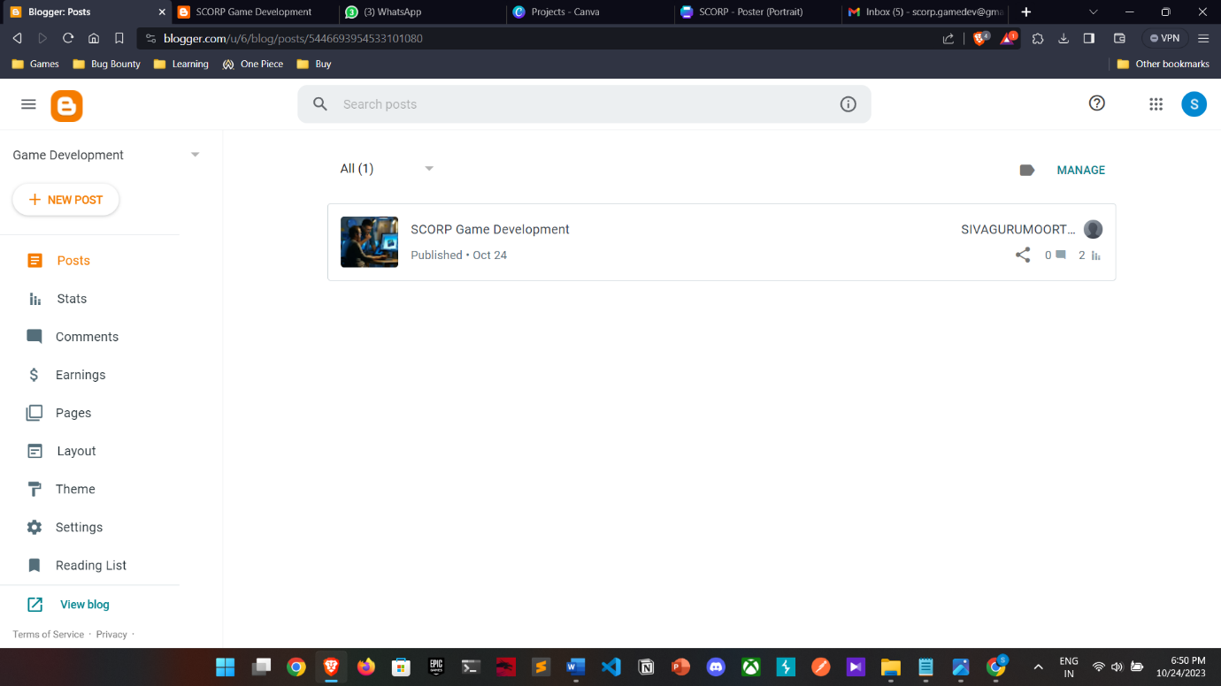

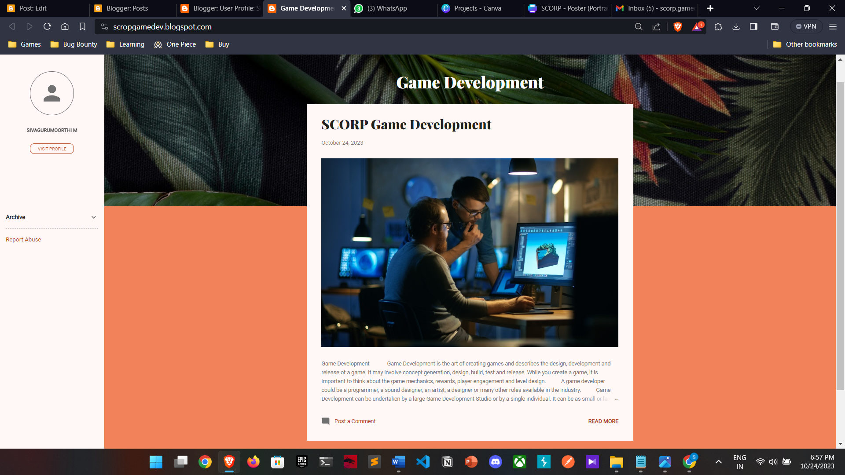

SCORP Game Development[: https://scropgamedev.blogspot.com/2023/10/scorp-game-development.html](https://trendingstylecollection.blogspot.com/2023/10/treading-collections.html)

Game Development is the art of creating games and describes the design, development and release of a game. It may involve concept generation, design, build, test and release. While you create a game, it is important to think about the game mechanics, rewards, player engagement and level design.

A game developer could be a programmer, a sound designer, an artist, a designer or many other roles available in the industry.

Game Development can be undertaken by a large Game Development Studio or by a single individual. It can be as small or large as you like. As long as it lets the player interact with content and is able to manipulate the game’s elements, you can call it a ‘game’.

1. Create a New Facebook Business Page and Post one Social media Poster for your Brand.

Facebook Business Suite: <https://business.facebook.com/latest/home?asset_id=170737382778942>

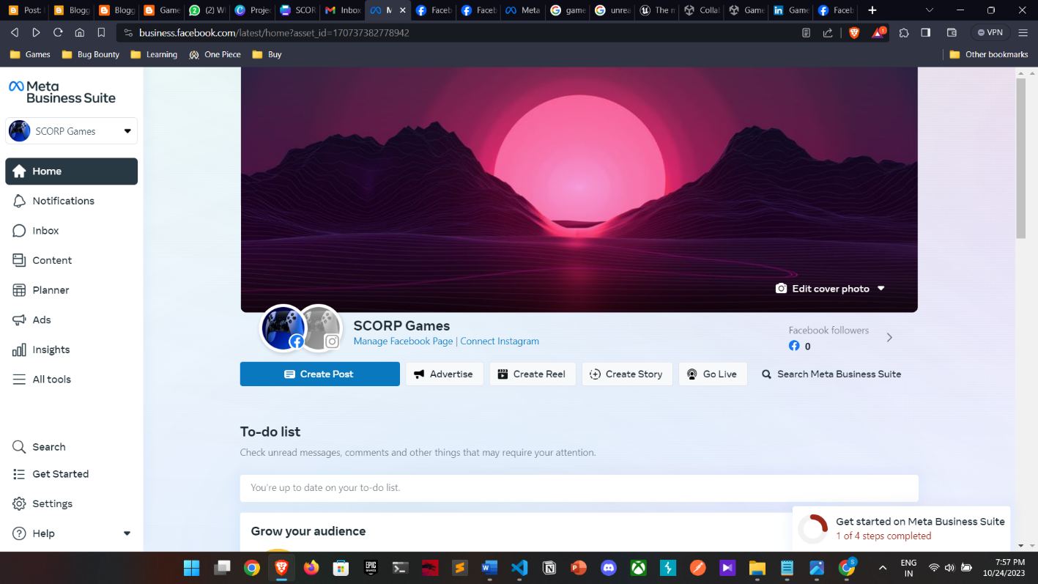

Facebook Page Profile: <https://www.facebook.com/profile.php?id=61552723499186>

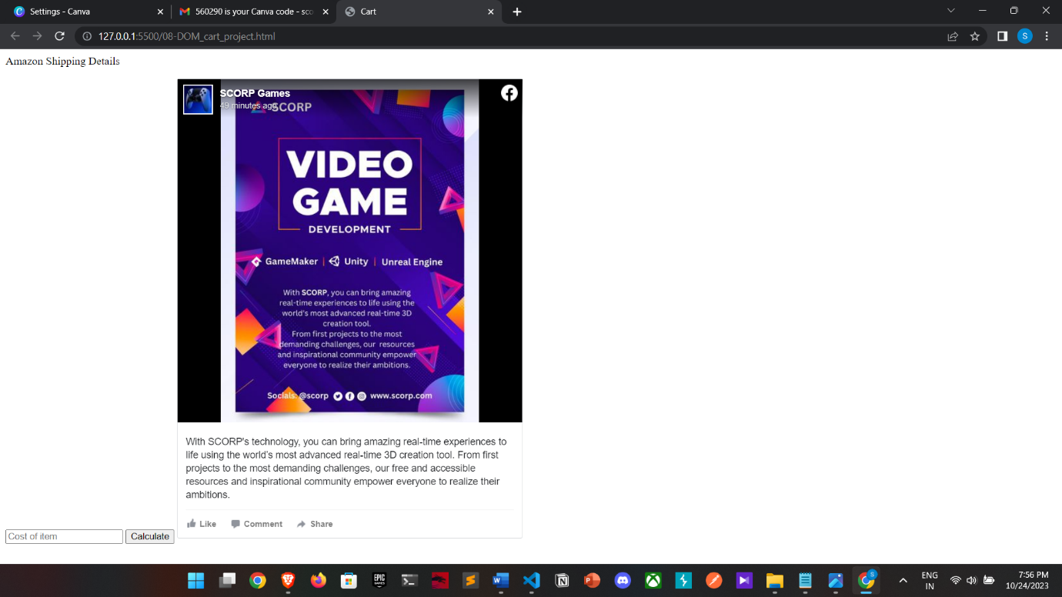

1. Create and design a social media advertisement poster using Canva.

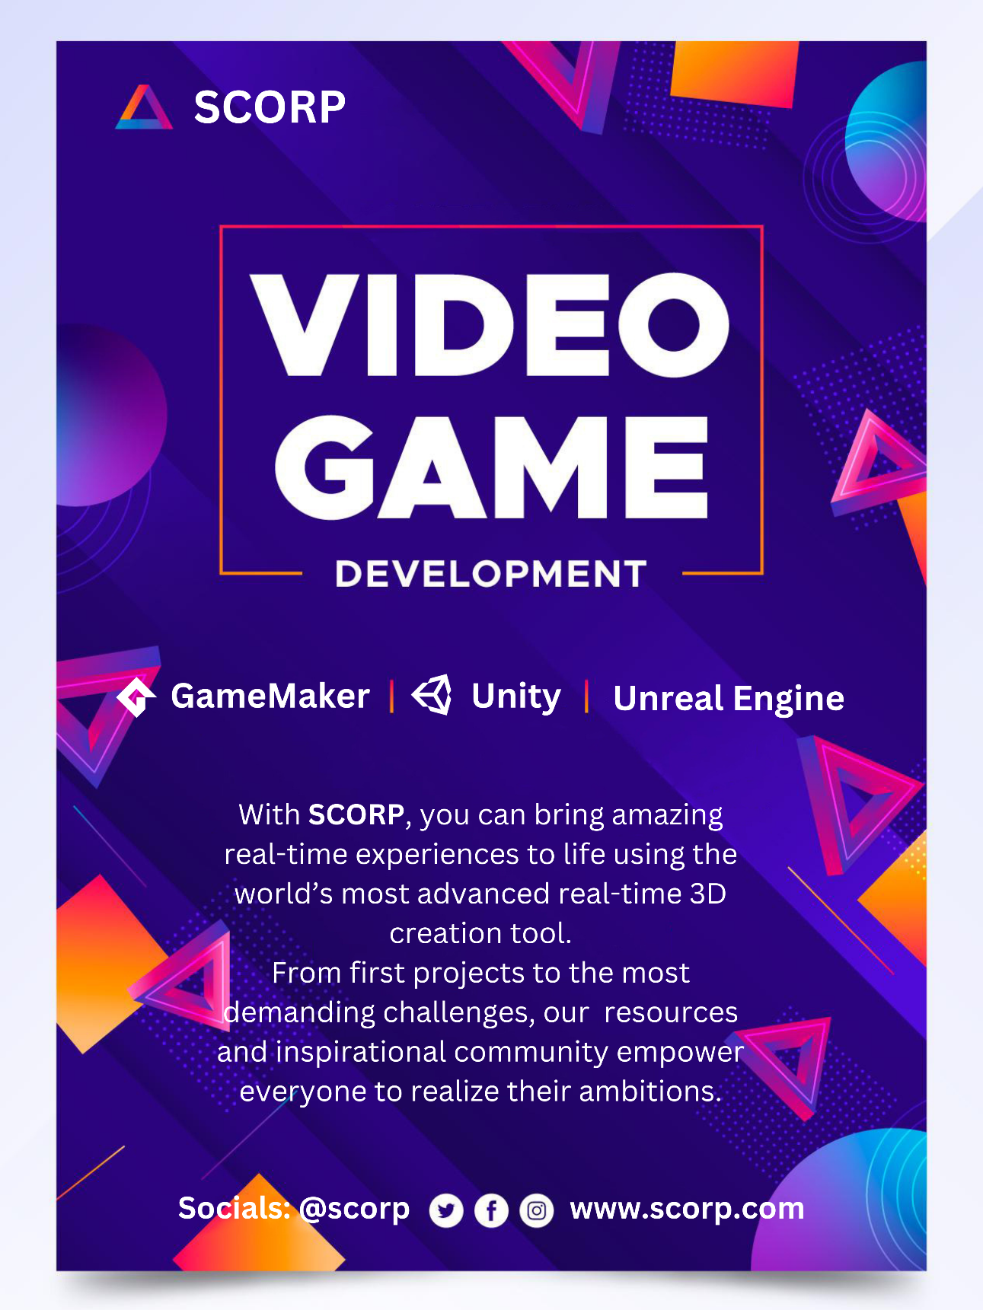

Design link: https://www.canva.com/design/DAFxOssIBhw/LdKfVhVdqcI2rvupksKIBQ/edit?utm_content=DAFxOssIBhw&utm_campaign=designshare&utm_medium=link2&utm_source=sharebutton

1. Create Email Newsletter Design Using Canva Tool

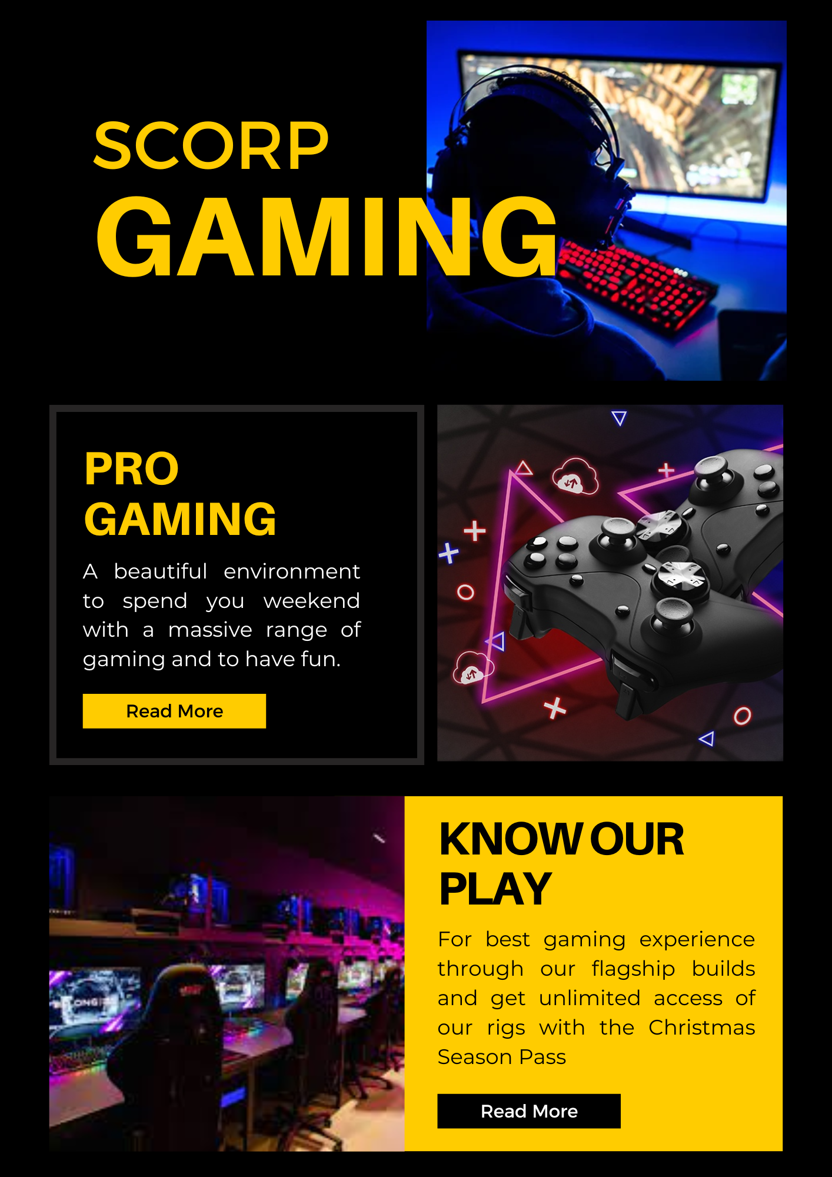

Design link: https://www.canva.com/design/DAFxsnFmzJU/FfVgZTFL4IXZ26pwQOqiTg/edit?utm_content=DAFxsnFmzJU&utm_campaign=designshare&utm_medium=link2&utm_source=sharebutton